DML Campus  OFFICE LEASE | 300 East 2650 North  North Ogden, Utah 84414

THIS OFFICE LEASE is made and entered into as of this __ day of ____________by and between DML Campus LLC (“Landlord”) and ________________________________ (“Tenant”).
W I T N E S S E T H:
WHEREAS, Landlord is the owner of the building commonly known as The DML Campus Building and located at 300 East 2650 North, North Ogden, Utah (the “Building); and
WHEREAS, Tenant desires to lease from Landlord, the covenants specified herein and Landlord desires to Lease to Tenant, certain premises in the Building.
NOW THEREFORE, in consideration of the premises and other good and valuable consideration, Landlord and Tenant agree as set forth below.
(1) PREMISES. Landlord leases to Tenant, and Tenant leases from Landlord, Suite #_____ and shown on Exhibit A (the “Premises”), in the Building.
(2) TERM. This Lease shall be for a term of __ months, commencing on _________________ (the “Commencement Date”) and ending at 11:59 p.m. ____ months after.
Except for the work specified on Exhibit B attached hereto (if none, specify “none” on Exhibit B), Landlord shall not be required to perform any work to prepare the Premises for Tenant’s occupancy and Tenant shall accept possession of the Premises in its “as is” condition on the date delivered by Landlord except as noted on Exhibit B. Lease is_ allowed to convert to month to month (Section 13).
(3) RENT. Tenant covenants and agrees to pay to Landlord, without demand, deduction or offset, base rent at a monthly rate of _ , ($_ _) Dollars (the “Base Rent”). Base Rent shall be payable on or before the Commencement Date and on or before the first day of each calendar month thereafter during the term of this Lease.

Base Rent for any partial calendar month during the term of this Lease shall be prorated based on the number of days in such partial calendar month. Rent increase notifications shall be provided 1 month in advance and review at term end, calendar year, or on each one year anniversary of this Lease. (Estimated increase 6% annually). Tenant shall pay Landlord, as additional rent, Tenant’s share of those costs and expenses identified on Exhibit C attached hereto (if none, specify “none” on Exhibit C). Tenant’s proportionate share of such costs shall be paid to Landlord at the same time lease payment is made. All amounts due before the 8th of the month. If Tenant fails to pay any Base Rent, additional rent (collectively with Base Rent, “rent”) or any other amounts payable hereunder when due, the unpaid amount shall bear interest from the due date to the date of payment at the greater of eighteen percent (18%) per annum or the highest interest rate allowed by law. In addition, if Tenant shall fail to pay any Base Rent or additional rent when due, Tenant shall pay Landlord a late fee equal to the greater of $200 or 5% of the amount past due.
(4) USE.
(a) PERMITTED USE. Tenant shall use the Premises exclusively for general office purposes for Tenant’s business and for no other use without Landlord’s consent, which consent may be withheld in Landlord’s sole discretion. Tenant shall at its sole cost and expense promptly comply with all laws, statutes, ordinances and governmental rules, regulations, and requirements now or hereafter in force, and with the requirements of the local Board of Fire Underwriters or any similar body now or hereafter constituted relating to or affecting the condition, use, or occupancy of the Premises. Tenant shall also comply with the rules and regulations of the Building (a current copy is found at www.dmlcampus.com ) and with such amendments thereto as may from time to time be established by Landlord (“Rules”).
(b) PROHIBITED USES. Notwithstanding any terms to the contrary contained herein, Tenant agrees that the Premises shall not be used for: manufacturing or similar; server host or similar computer farm or facility; storage of any hazardous materials or wastes. All signage shall be approved in advance and conform with city ordinances. No Open flames or candles allowed . Activities that disrupt other tenants.
.
(c) KEYS. Tenant shall receive a set number of keys to Premise and shall be responsible for the protection and safety of the keys. Tenant may be liable for all costs of re-keying and securing the building for any lost, stolen, or copied keys within their responsibility. Keys are not to be copied. Additional keys will be provided upon request and justification. Audits may be required periodically to account for all keys and personnel requesting building access. Tenants security is paramount.
(5) COMMON AREAS. Tenant and its employees, customers and invitees shall have the reasonable non-exclusive right to use (in common with Landlord and all others to whom Landlord may grant such rights) such stairways, corridors, restrooms, lobby, break room, and other common areas and facilities as may from time to time exist and be generally available to all tenants of the Building. Landlord shall have full control, management and direction of the common areas and facilities. Landlord shall have the right to close, reduce, increase, enclose, or otherwise change the size, number, location, layout, and nature of the common areas and facilities in the Building; to place signs or decorations on or in the Building; and to change the name, number or designation by which the Building or Premises is commonly known.
(6). UTILITIES AND SERVICES. Subject to the Rules, Landlord shall, at its expense, provide: (a) heat and air-conditioning to the Premises; (b) water for the intended use of the Premises; (c) janitorial service for the Building; (d) electrical power; and (e) high-speed internet connectivity; and other services outlined on Exhibit (C). Landlord shall not be liable for Landlord’s failure to furnish any of the foregoing services when such failure is caused by any cause beyond the reasonable control of Landlord. Any services, other than those agreed herein to be provided by Landlord shall be paid for by Tenant. A cleaning deposit equal to one month’s rent shall be held non-interest bearing by Landlord pending repairs or refurbishment for the amount of one month rent ($_______).
(7) REPAIRS. Landlord shall keep the common areas in good condition and repair and shall make all structural and exterior repairs to the Premises and all repairs to the heating, air-conditioning, ventilating, electrical, and plumbing equipment and facilities located in the Premises; provided, however, if any part of the Building (including the Premises) or the apparatus or equipment therein requires repair or becomes damaged or destroyed through the acts, omissions, negligence or willful misconduct of Tenant or its agents, employees, customers or invitees, the expense of the necessary repairs, replacements or alterations shall be paid by the Tenant. Except as provided above, Tenant shall, at its expense, keep the Premises in good condition and repair. Annually, near the anniversary of the Lease, the Tenant premises shall be inspected for required repairs or refurbishment, and the costs of such shall be paid by the Tenant.
(8) IMPROVEMENTS AND ALTERATIONS. Tenant shall not make any alterations, additions or improvements in, on, or to the Premises or any part thereof without the prior written consent of Landlord. Sticky-tac, tape, or similar adhesives are not to be used on the dry-erase walls, premise walls or painted regions. Dry-erase Walls shall not be punctured by any means. Note: using the dry-erase walls as a writing surface using a pen will damage the surface.
(9) ASSIGNMENT AND SUBLEASE. Tenant shall not assign its interest under this Lease or sublease all or any part of the Premises without the Landlord’s prior written consent. Notwithstanding Landlord’s prior written consent to any assignment or sublease, Tenant shall remain liable to Landlord for the payment of rent and the performance of all other obligations of Tenant hereunder for the balance of the term hereof.
(10) DIRECTORY AND SIGNS. Tenant shall be entitled to have its name shown upon the entrance sign and the directory board of the Building. The design, size and style of identification, the location of the directory board, and the allocation of space thereon among the tenants of the Building, shall be determined by Landlord. Tenant shall not, without Landlord’s prior written consent, install any sign or any other improvement on the exterior or in the interior of the Premises. Tenant is responsible for invoiced printing and signage costs. Tenant is to provide print-ready artwork, logos, signage design.
(11) INSURANCE AND MUTUAL WAIVERS OF SUBROGATION. Tenant shall, at its expense, obtain and carry at all times during the term of this Lease: (a) public liability insurance covering the Premises and Tenant’s use thereof with limits of at least $1,000,000 combined single limit of liability for any bodily injury or death of any person(s) and any property damage for one occurrence (or such higher amounts as Landlord shall from time to time determine), and (b) such other insurance as may be required from time to time by Landlord or Landlord’s mortgagee. All of such policies shall name both Landlord and Tenant as insureds, as their interest may appear, and all insurers thereon shall agree not to cancel or change the policies without at least twenty (20) days prior written notice to Landlord. A certificate of insurance of Tenant’s insurers evidencing such insurance shall be furnished to Landlord on or before the Commencement Date and, thereafter, a certificate evidencing the renewal of such insurance shall be furnished to Landlord at least thirty (30) days prior to the expiration of the term of each such policy. Whenever any loss, cost, damage, or expense is incurred by any party to this Lease and such party is then covered in whole or in part by insurance with respect to such loss, cost, damage, or expense, then the party so insured hereby releases the other party from any liability it may have on account of such loss, cost, damage, or expense to the extent of any amount recovered by reason of such insurance and waives any right of subrogation which might otherwise exist in or accrue to any person on account thereof, provided that such release of liability and waiver of the right of subrogation shall not be operative in any case where the effect thereof is to invalidate such insurance coverage (or increase the cost thereof, unless the other party reimburses the insured for any cost increase).
(12) INDEMNIFICATION/NON-LIABILITY OF LANDLORD. Tenant shall indemnify, defend and hold harmless Landlord, its agents and employees (the “Landlord Indemnified Parties”), from and against all claims, liabilities, losses, damages and expenses, including attorneys’ fees and court costs, brought against or incurred by any Landlord Indemnified Parties arising out of, relating to or occurring by reason of Tenant’s use or occupancy of the Premises or occasioned wholly or in part by any act or omission of Tenant, its agents, employees or invitees. Except for the intentional acts of the Landlord Indemnified Parties, the Landlord Indemnified Parties shall not be liable for, and Tenant, its agents, employees or invitees waive all claims for, injury to persons or damage to property sustained by Tenant, its agents, employees or invitees resulting from, arising out of or relating to an accident or occurrence in the Building or in the vicinity thereof.
(13) HOLDING OVER. Tenant, if it elects, shall holdover as an extension of this lease for a period from month to month, on the same terms and conditions of this lease as identified in section three (3). This provision shall not be deemed to waive Landlord’s right of re-entry or any other right hereunder or at law. Holding Over does not preclude Landlord from showing Premises or ending month to month extensions in favor of securing another Tenant with other term lease conditions.
(14) SUBORDINATION. This Lease is and shall be subject and subordinate at all times to the lien of any mortgage (including all extensions, renewals, amendments and supplements to any mortgage) in any amount now or hereafter placed on or against the Building, without the necessity of the execution and delivery of any further instruments on the part of Tenant. Tenant covenants and agrees to execute and deliver upon demand such further instruments evidencing such subordination and/or estoppel certificates as may be requested by Landlord.
(15) ENTRY BY LANDLORD. Landlord reserves the right to enter the Premises to inspect the same; to supply any service to be provided by Landlord hereunder; to show the Premises to prospective tenants, purchasers, or mortgagees; to post notices of non-responsibility; and to decorate, alter, improve, or repair the Premises and any portion of the Building, all without abatement of rent. For each of the aforesaid purposes, Landlord shall at all times have a key with which to unlock all of the doors in the Premises, and Landlord shall have the right to use any and all means which Landlord may deem necessary to open such doors as deemed necessary by the Landlord.
(16) TENANT DEFAULT. If: (a) default be made in the payment of Base Rent or any additional rent or charge payable hereunder to Landlord by Tenant, and such default shall continue for five (5) days after written notice thereof shall have been given to Tenant; or (b) default be made in any of the other terms, covenants or conditions herein contained on the part of Tenant and such default shall continue for fifteen (15) days after written notice thereof shall have been given to Tenant; or (c) if this Lease shall, by act of Tenant or by operation of law or otherwise, devolve or pass to any party other than Tenant, except with the prior written consent of Landlord; or (d) if Tenant shall abandon or vacate the Premises or permit same to become vacant; then and in any of the above-described events, Tenant shall be in breach of this Lease, and Landlord shall have the rights and remedies herein provided and any other rights or remedies as may be provided at law, in equity or otherwise. Tenant default shall result in forfeiture of prepayments and/or deposits to fulfill obligations. All costs and expenses, including attorneys’ fees, incurred by Landlord in enforcing any of the terms, covenants or conditions of this Lease or pursuing any remedies or pursuing any remedies available hereunder, shall be payable to Landlord from Tenant on demand. Failure of Landlord to exercise its rights in connection with any breach of this Lease shall not be deemed to be a waiver of such breach or any other term, covenant or condition herein contained, and the subsequent acceptance of rent hereunder by Landlord shall not be deemed as a waiver of any preceding breach by Tenant of any term, covenant or condition of this Lease. Tenant default or suspected default, hereunder allows Landlord to initiate steps to protect self and other tenants for financial loss, security compromise, or any other negative aspects caused by the Tenant default. Such steps may include changing locks without notification, towing vehicles, securing premises, barring access or entry, stopping services, or any other security or physical actions as determined necessary by Landlord.
(17) SALE BY LANDLORD. In the event of a sale or conveyance by Landlord of the Building, the same shall operate to release Landlord from any future liability under any of the covenants or conditions herein contained. In such event, Tenant agrees to look solely to the successor in interest of Landlord in and to this Lease. This Lease shall not be affected by any such sale or conveyance. Tenant agrees to attorn to the purchaser or grantee, which shall be personally obligated on this Lease only so long as it is the owner of Landlord’s interest in and to this Lease.
(18) NOTICES. All notices and demands which may or are required to be given by either party to the other hereunder shall be in writing and given by personal delivery, left in premise, sent via facsimile, or sent by overnight courier. Notices and demands to Landlord and Tenant shall be personally delivered or addressed as follows:
If to Landlord: DMLGroup Campus Manager
300 East 2650 North Suite #250
North Ogden, Utah 84414

If to Tenant: __________________________
__________________________
__________________________

with a copy to: __________________________
__________________________
__________________________
All such notices and demands shall be deemed to be given on the date such notice is personally delivered, emailed, facsimile transmission, or one business day following deposit with an overnight courier.
(19) SURRENDER OF PREMISES. Upon the termination of this Lease, Tenant shall surrender the Premises and keys to Landlord in as good condition and repair in a broom-clean condition as when delivered by Landlord, ordinary wear and tear and damage by insured fire and other casualty excepted. All alterations, additions, improvements and decorations made to the Premises by or for Tenant shall remain and become the property of Landlord unless Landlord shall require Tenant, at Tenant’s expense, to remove any or all thereof and repair the damage caused by such removal. All trade fixtures and other equipment and personal property owned by Tenant may (and, upon Landlord’s request, shall) be removed from the Premises by Tenant no later than the termination date. Any trade fixtures, equipment and personal property not removed by Tenant on or prior to the termination date shall be deemed abandoned and shall become the property of Landlord, but without prejudice to Landlord’s continuing right to require Tenant to remove the same at Tenant’s expense. Landlord shall inspect surrendered Premises and the cleaning deposit returned within forty-five (45) days pending any deductions for cleaning, repairs, and refurbishment.
(20) DAMAGE OR DESTRUCTION/CONDEMNATION. If any material part of the Building shall be taken in condemnation or destroyed or damaged by fire or other casualty, Landlord shall either (i) diligently proceed to repair or restore the basic structure and facilities of the Building to the condition in which they existed immediately prior to such destruction, damage or taking or (ii) elect in its sole discretion not to repair or restore the Building and to terminate this Lease, effective as of the date of the destruction, damage or taking. In the event of a taking, all damages awarded by the acquiring authority shall be the property of Landlord; provided, however, that Landlord shall not be entitled to any separate award which may be made to Tenant for the cost of realigning, relocating or removing its personal property.
(21) QUIET ENJOYMENT. So long as Tenant shall perform and observe all of its obligations under this Lease, Tenant shall quietly enjoy the Premises, subject to the terms of this Lease and subject and subordinate to any zoning laws, ordinances, regulations, building restrictions, easements for public utilities and any underlying mortgages which may now or hereafter affect all or any part of the Building.
(22) RELOCATION RIGHT. Landlord shall have the right prior to and during the term of this Lease to substitute other premises (the “Other Premises”) at the DML Campus for the Premises. The Other Premises shall be reasonably comparable in size to the Premises. If the Other Premises contains more or less floor area than the Premises, the Rent shall be adjusted on the basis of the rent per square foot then being paid by Tenant for the Premises. Landlord shall give Tenant at least thirty (30) days prior written notice of the substitution of the Other Premises for the Premises, which notice shall describe the Other Premises, any rent adjustment and the effective date of the substitution. If Landlord directed relocation, Landlord shall provide moving services to move Tenant from the Premises to the Other Premises. Tenant agrees to surrender the Premises to Landlord in a broom-clean condition on the effective date of the substitution.
(23) MISCELLANEOUS.
(a) Except as otherwise specifically provided herein, whenever the consent or approval of Landlord is required to be given hereunder, Landlord may grant or withhold such consent or approval in its sole discretion.
(b) The laws of the state of Utah in which the Building is located shall govern the validity, performance and enforcement of this Lease.
(c) The invalidity or unenforceability of any provision of this Lease shall not affect or impair any other provision.
(d) This Lease shall become effective and binding only upon the execution and delivery hereof by Landlord and Tenant.
(e) The covenants, agreements, and obligations contained in this Lease, except as herein otherwise specifically provided, shall extend to, bind, and inure to the benefit of the parties hereto and their respective personal representatives, heirs, successors, and assigns (but in the case of assigns only to the extent that assignment is permitted hereunder).

Executed as of the day and year first above written.

Landlord: DMLGroup Campus, LLC.  By:  Its:  Date: | Tenant:  By:  Its:  Date:

EXHIBIT A: Map of Premises

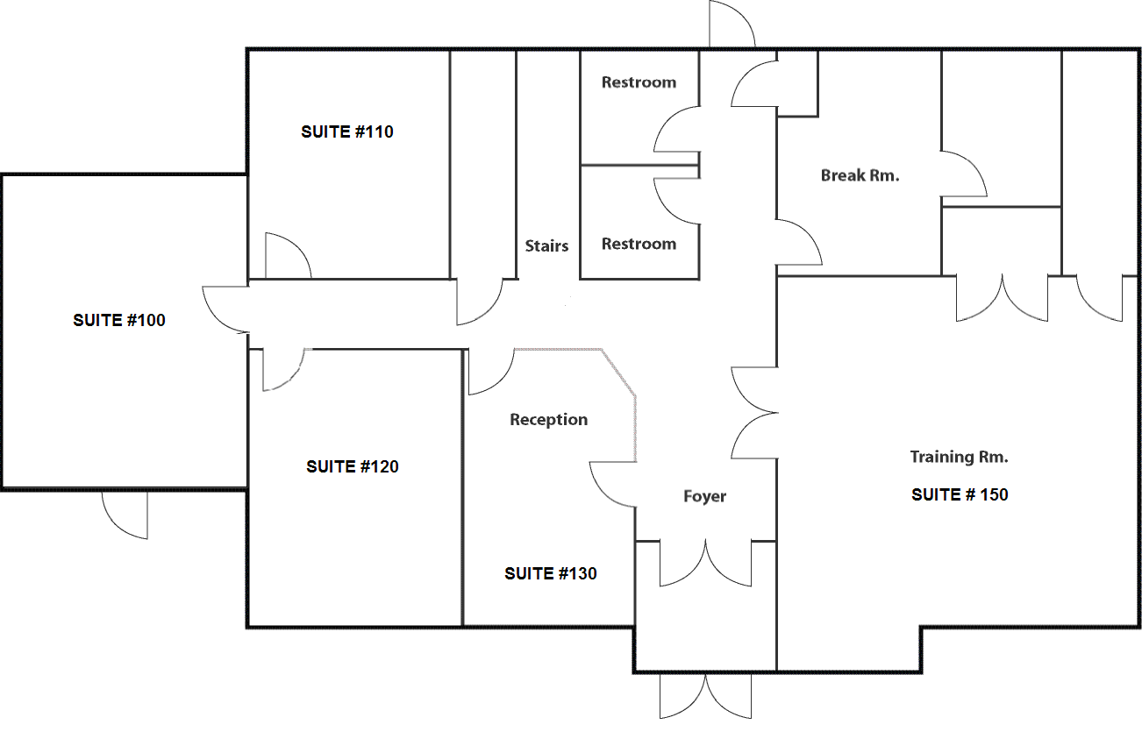

First Floor

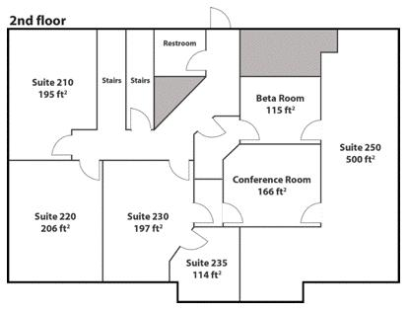

Second Floor

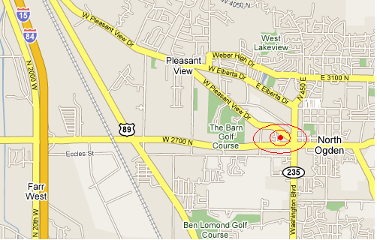

DML Campus

300 East 2650 North

North Ogden, Utah 84414

EXHIBIT B: Work Specified

FURNISHED:

Furnished equipment includes:
_______________________________________________________________________
_______________________________________________________________________
_______________________________________________________________________
_______________________________________________________________________

NOTE:
- Tenant will need to provide carpet protectors for each desk workstation.

Deposit $________
First month rent $ ________ (pro-rated for move in day).
Move in date: _____________

Security System Change Fee: $25.00
Provide 3 four-digit PIN numbers for your security system selection. Hopefully one of these codes will be available. You will be notified which code is implemented at the security company. __ __ __ __ __ __ __ __ __ __ __ __

Select your Security System password. It cannot be part of your or the company name. This is a code word to be given only to the security company in the event of alarm triggering. _____________.

Security System contact name and cell phone(s):

Names of Individuals Given Key Access: __________________________________
EXHIBIT C: Rents and Surcharges
(Subject to Change with notice)
Description | Amount | Notes
Base rent (Suite #_______ ) | Variable ($_____ base) | Payable the first week each month or prior
Base utilities (electricity and natural gas) plus Surcharge | Variable – breakroom supplies, consumption, and utility rate hikes adjustments | Base Included. The quantity of individuals/ equipment, may require a surcharge of up to $20 per person excess consumption.
High-Speed Internet Access (Web Site included). | Base backbone Included. | Excess usage or needs will require an additional fee based on services. Please discuss quantity/frequency of bandwidth consumption.
Catering Surcharge | Variable
Extra Cleaning Surcharge | $50 per hour
Security System Type I or Type II breach or false alarm | $75.00 per incident | $25.00 alarm change program fee
Key/Rekey Fee | $50.00 per door + T&M
Networking Assistance | $50.00 per door + T&M

EXHIBIT D: Tenant Rules

NOTE: The most current Tenant Rules are posted on www.dmlcampus.com.

Campus is a non-smoking area (both in buildings and on grounds). Standard Campus hours are 8:00 am to 6:30 pm Monday through Friday. After hours access is available to Tenants with keys and alarm code information.

Building doors are secured at 6:30 p.m. by any Tenant leaving the building M-F and 5:00 pm Sat. Each Tenant leaving the building will check the door and ensure the deadbolt is locked for after hours. After-hour customer/client visits are to be arranged so a Tenant is in the building at all times that the customer/client is in the building. Doorbells are available for after-hour visitors. Last Tenant to leave checks all doors are deadbolt locked.

Break-room is a common area. All lunches must be stored in a leak-proof, closeable container in the common fridge with the person’s name and suite number identification.

Lights are to be turned off if not in current use. Suite and floor interior lights to be turned-off when you leave. Note: bathroom lights have automatic sensors and will turn-off after a few minutes. Please leave bathroom doors open. The light above first floor TV/monitor may be left on.

Food left open (e.g., condiments) may be commonly used. Plastic-ware, plates, and cups are available for use. Do not waste products.

Fridges are cleaned out by janitorial services and containers and/or food may be thrown out to keep the fridge clean.

Water cooler bottles are not to be removed from the building or used for any other purpose then for the water coolers.

All vandalism or security breaches are to be reported immediately. Each Tenant responsible for security system activation/deactivation for their premises at all times.

Chair-carpet protector floor mats required under all chairs used more than 1-hour a day.

Trash cans are on East of building. If any services are needed for restrooms or other common areas, please notify DMLCampus manager or David (801.391.5479).

Doors are to remain locked during after hour visits while Tenants are in the building. Tenants are responsible for ensuring that their Suite doors and windows are locked appropriately each night and the alarm is turned on. Note: if your door is not secured and the alarm is triggered for the suite, you will be responsible for alarm service call fee.

Invoices for lease and extra services/surcharges are provided monthly as needed. Payment due upon receipt. Monthly payment expected first few working days at the beginning of each month. Place check in envelop and slide under #250 door. Statements provided upon request.

